Brian Dones

Professor Cannistra

Internetworking



Lab Journal 06

**Journal Description:** In this lab, we will be utilizing Cisco Packet Tracer to create a topology where we cable and configure a Dallas, New York, and Chicago router together implementing EIGRP routing protocol. From the Dallas router, we have a “Router-on-a-stick” topology where we have a switch with two PCs connected to the router. We will be configuring this “Router-on-a-stick” topology with VLAN networks – one for each PC connected to the switch. Connected to our Chicago router is a interVLAN network where we have two layer-two switches with two PCs each connected to a layer-three switch that is cabled to our Chicago router.

**Topology:** Below is a picture of the topology we are setting up. You can also view this in the **LabJournal06.pkt** file.

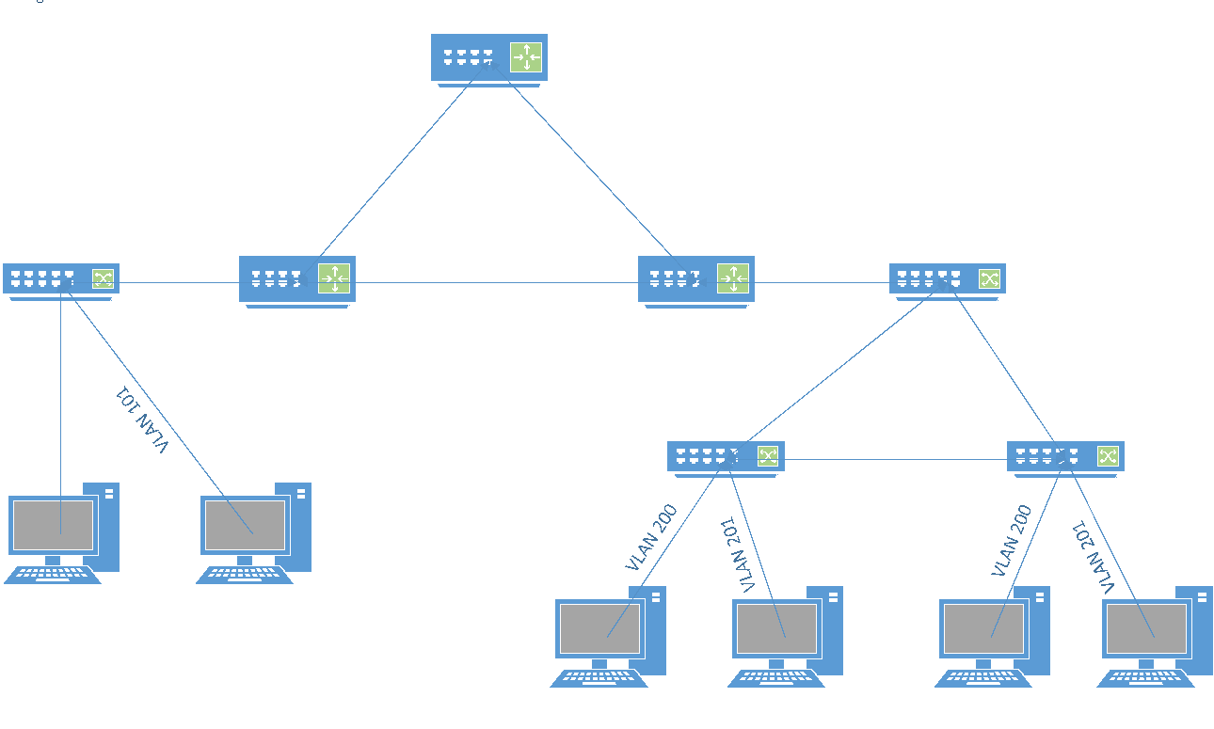

**Table of Command Syntax:**

|  |  |
| --- | --- |
| Command | Description |
| Ping | Used for testing connectivity to a device |

**Verification:** To verify that we have connectivity among the PCs throughout the entire topology, we need to ping the PC

**Results and Outcomes:** This lab was fairly straight forward so there were no difficulties in creating this topology. All we had to do was assign both PCs their respective IP Address and Subnet Masks and connect both PCs using a crossover cable. After doing this, we are able to successfully ping from one PC to the other PC ensuring that we have connectivity.